**DAT 410 Homework Two: Data Visualization**

After completing the guided analysis plan in Homework Assignment One: Data Prepping and Planning, you will capture the results in a visual form for items 1–5.

**For this assignment**: Submit a Microsoft Word document in which you have captured the results of items 1–5 from Homework One in a visual way. With each visualization, include the actual question the visualization is addressing from Homework One and any notes or thoughts regarding the findings. Additionally, consider questions a lay person might have when viewing one of the visualizations and answer those questions as part of the story in an ordering that does not cause confusion.

Although you can choose other visualization tools, the following are step-by-step instructions using

Tableau Public. Some other options are JMP, QlikView, and Excel. If you choose to use QlikView or PMP Pro, please use the virtual desktop by following [these instructions](https://learn.snhu.edu/d2l/lor/viewer/view.d2l?ou=6606&loIdentId=15847).

**Tableau Public Prep:** To start the analysis, open Tableau Public from your Programs (Windows) or Applications (Mac) folder. See installation steps in the technical information document in Module One if Tableau Public is not yet installed.

When the application opens, go to the top toolbar and click **DATA** → **Connect** or click the **Data** tab located to the left of the home tab (shown in Figure 1).

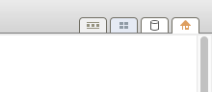

Figure 1

In the Connect tab, on the left menu bar, select **In A File** → **Microsoft Excel**. Using the file explorer that opens, navigate to the directory where you save the HOMEWORK2_DATA_DAY.xlsx file and select it.

On the left panel, there will be the day and temp sheet listed. Drag and drop the day sheet to the box on the top that says **Drag Sheet Here**. Your screen should look similar to Figure 2.

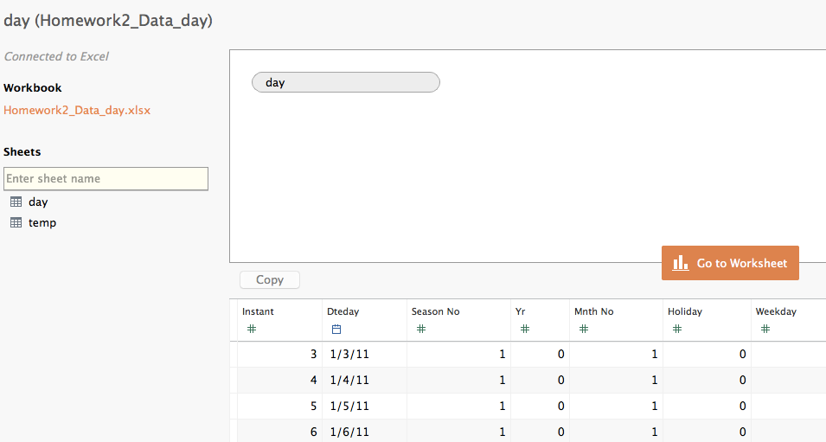

Figure 2

Click the **Go to Worksheet** button to begin visualization.

Repeat these steps for HOMEWORK2_DATA_HOUR.xlsx. Note that this is a large file and could take about three to five minutes to upload and display depending on your connection speed.

You will be able to switch between data files by clicking the file you want to use in the top left corner of the worksheet, as shown in Figure 3.

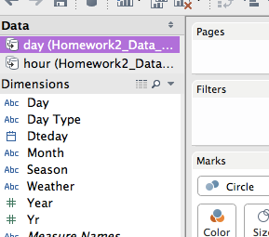

Figure 3

**Q1-Visualization:** For an initial visualization, select the **HOMEWORK2_DATA_DAY.xlsx** dataset at the top right of the worksheet in the Data area. In the worksheet, drag CNT to the larger data square. Click on down arrow and change Measure to Average. Drag DteDay to Columns and set to YEAR by right clicking and using the dropdown menu. Drag Season to Rows.

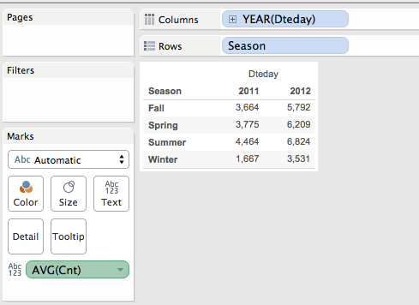

Figure 4

On the right graph options, click on the bar graph.

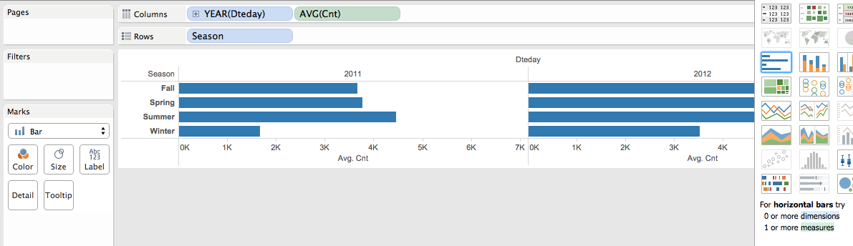

Figure 5

From this view, select **Side by Side Graph** to get the visualization.

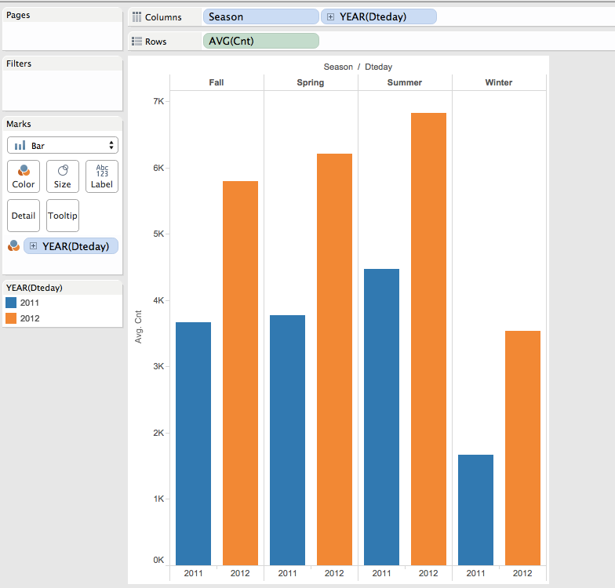

Figure 6

Practice is the only way to learn. Continue using these three variables and select other graphs. Move the variables to different arrangements of columns, rows, and markers. Continue this and capture a visualization(s) you would use to present to a decision maker in support of this posed question. Note: While you are practicing, you can go to the top menu and select **WORKSHEET**→**CLEAR**→**SHEET** and simply start over.

**Q2-Visualization**

Go to the top menu and select **WORKSHEET**→**CLEAR**→**SHEET** to begin. Select the **HOMEWORK2_DATA_DAY.xlsx** dataset at the top right of the worksheet in the Data area. Drag DAY to Columns and CNT to Rows. Make sure bar chart is selected. Using the down arrow for CNT, change Measure to MAX. Drag CNT to Rows again and using the down arrow, change Measure to AVG. Drag CNT to Rows again and using the down arrow, change Measure to MIN. The visualization in Figure 7 is produced and provides all three MAX, AVG, MIN by day in one chart.

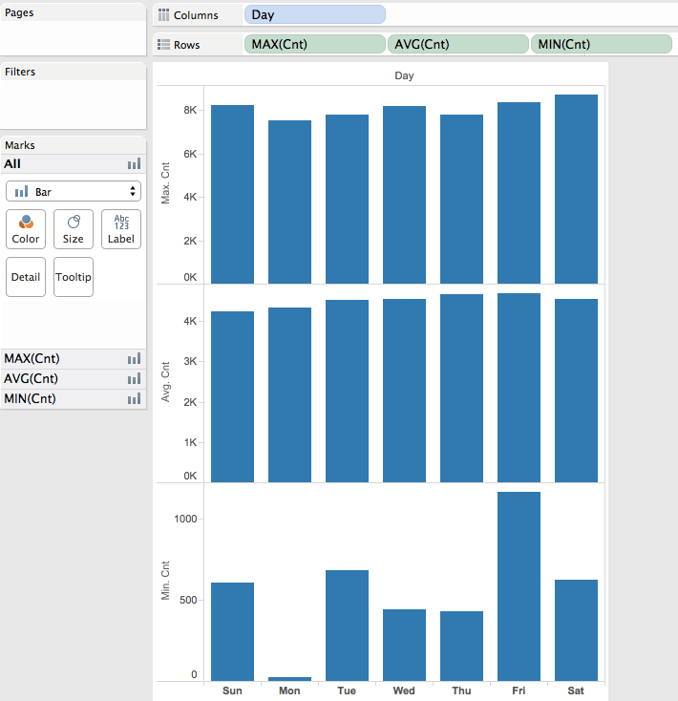

Figure 7

Next, select packed bubbles chart and drag DayType to Columns and Season to Rows. On the left in the Marks area, include AvgCnt—make sure it is set to Size. Include Weather and Day and set to Label. Include Weather again and set as Color. The visualization in Figure 8 is generated.

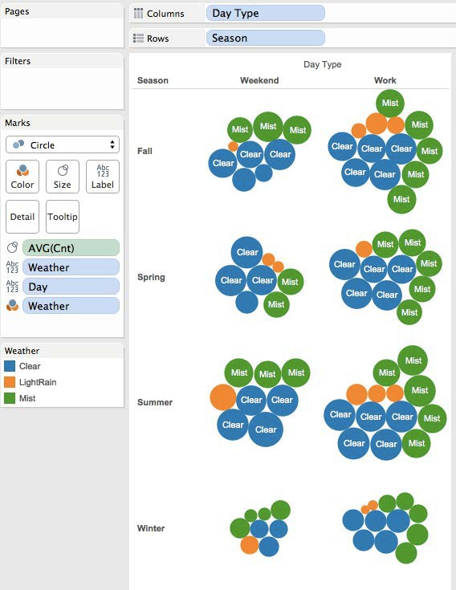

Figure 8

Continue using these variables to practice and try different types of charts and variable combinations. Capture your visualization(s) that you would provide to the decision makers.

**Q3-Visualization:** Go to the top menu and select **WORKSHEET**→**CLEAR**→**SHEET** to begin. Select the **HOMEWORK2_DATA_HOUR.xlsx** dataset at the top right of the worksheet in the Data area. Right click on **Hour** in the bottom left measure panel and change Convert to Dimension. Drag Hour to Rows. Drag Day to Columns. Drag CNT to Grid. Click the down arrow on CNT to change Measure to Average.

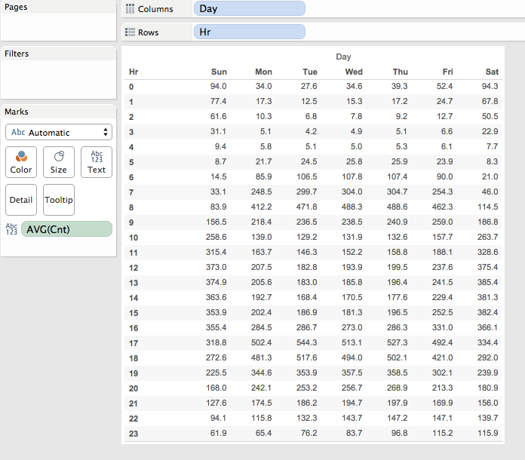

Figure 9

To begin to visualize, click on the stacked column chart. This visual shows a quick distribution of average count by hour for all days stacked.

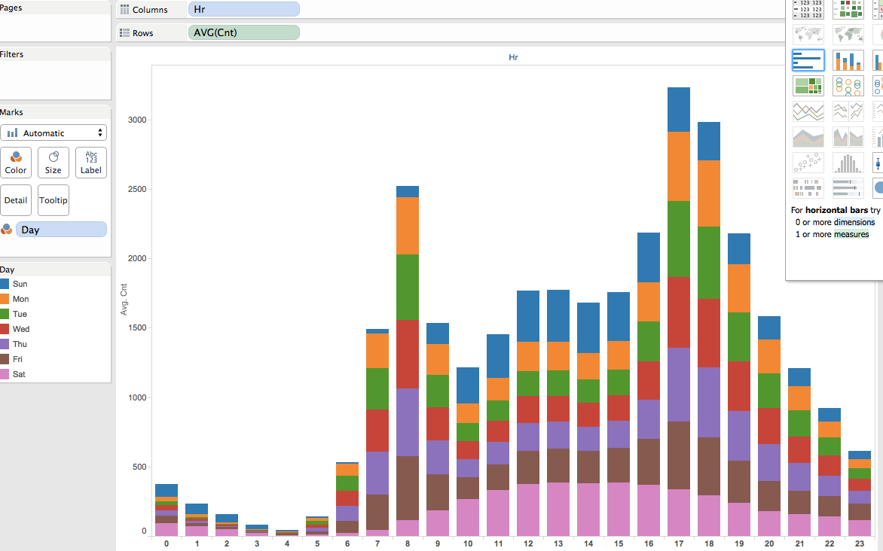

Figure 10

Go to the top menu and select **WORKSHEET**→**CLEAR**→**SHEET**. Drag Hr to Columns. Drag Day Type to Rows. Double click on **Casual**. Double click on **Registered**. Click the down arrow on each Casual and Registered and change Measure to Average. Drag Measure Values from Marks to Rows. Drag Measure Names from Rows to Marks. Move mouse to left of Measure Names in Marks. Click the down arrow and select Color. The visualization result in Figure 11 shows a stacked bar of average counts of Registered (orange) and Casual (blue) over each hour and further segmented by weekend and weekday groupings.

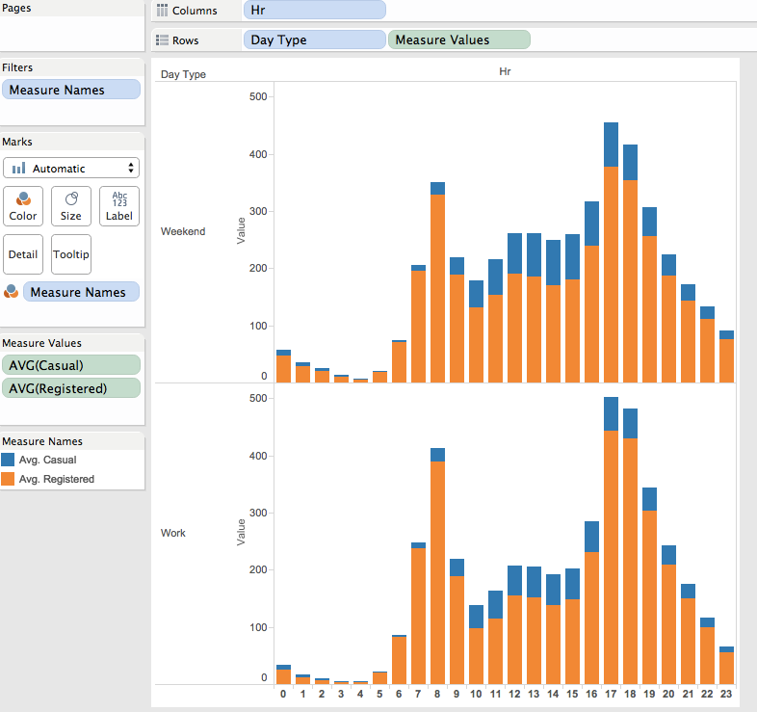

Figure 11

Continue using these to practice and try different types of charts and variable combinations. Capture your visualization(s) that you would provide to the decision makers.

**Q4-Visualization**

Go to the top menu and select **WORKSHEET**→**CLEAR**→**SHEET** to begin. Drag DteDay to Columns and CNT to Marks. Using the dropdown arrow on DteDay, select MONTH. Using the down arrow of CNT, select **Quick Table Calculation**→**Rank**. Using the down arrow of CNT, select **COMPUTE USING**→**Table(Down)**. The table will be sorted by month. To sort by rank descending, select the highlighted icon as shown in the Figure 12.

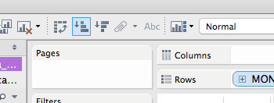

Figure 12

The results will look as follows:

Figure 13

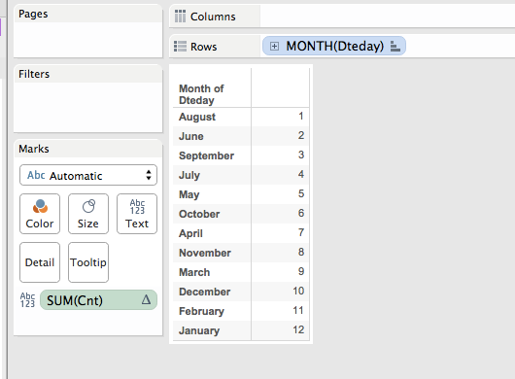

To perform a visualization of this data, select a bar graph and move the Month to Columns and the Rank of Cnt to Rows. Sort the data as before using the icon in the toolbar.

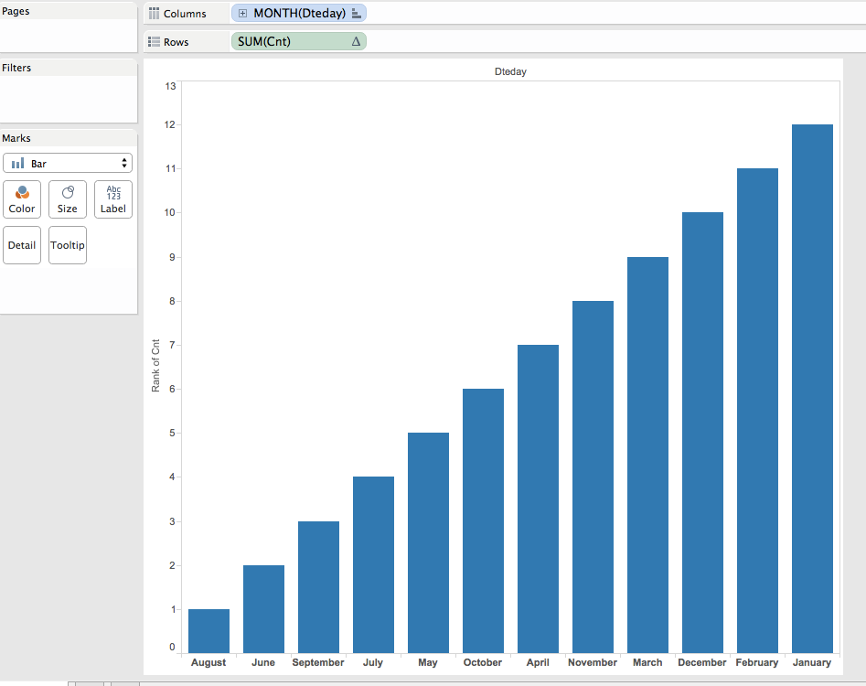

Figure 14

You further want to understand how the temperature overlays on the rank ordering of months. Drag TEMP into the chart with the blue bars and on the left panel, use the dropdown arrow on TEMP to change MEASURE to Average. Ensure that Color is selected for the AVG(Temp). The chart will change the

color gradation to go from light to dark for cold to hot. The higher ranked months are the darkest and therefore the hottest.

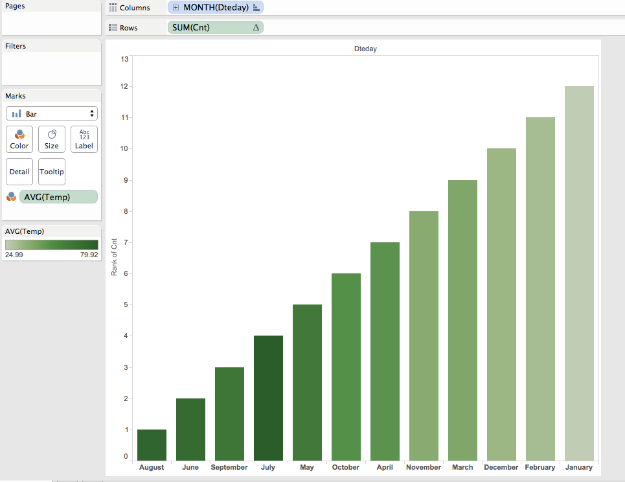

Figure 15

Make sure to capture the visuals you want to include for the decision makers.

**Q5-Visualization:** Go to the top menu and select **WORKSHEET** → **CLEAR** → **SHEET** to begin. Select the **HOMEWORK2_DATA_HOUR.xlsx** dataset at the top right of the worksheet in the Data area. Drag Day to Row. Double click **Casual**. Double click **Registered**. Using the down arrow for each Casual and

Registered, select **Measure** → **Average**. The table in Figure 16 is generated.

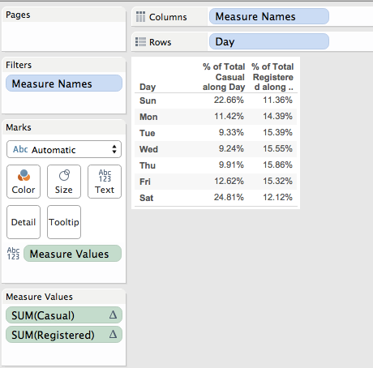

Figure 16

Add Hour to the table. Drag Day to Columns before Measure Names. Drag Hr to Rows. The table in Figure 17 is generated. It provides percentages in a day by hour grid for each registered and casual users. The users are split to provide percentages for planning and extrapolations.

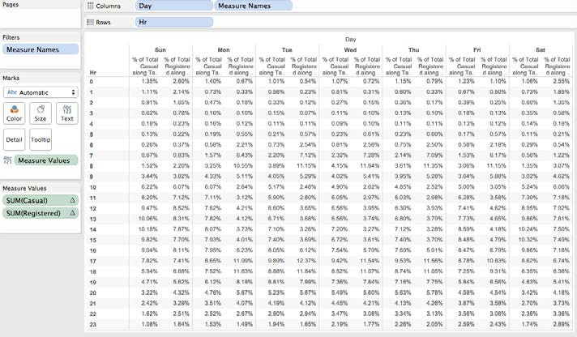

Figure 17

To visualize the information, Go to the top menu and select **WORKSHEET**→**CLEAR**→**SHEET**. Drag Hr to Columns. Drag Day to Rows. Double click **Cnt**. Double click **Registered**. Moving mouse to the left of Cnt, use the dropdown to select **Size**. Move the mouse to the left of Registered, use the dropdown to select

**Color**. The visualization in Figure 18 represents the Cnt in size of squares by day across hours and is colored darker where registered users are larger and lighter where registered users are smaller by day and by hour.

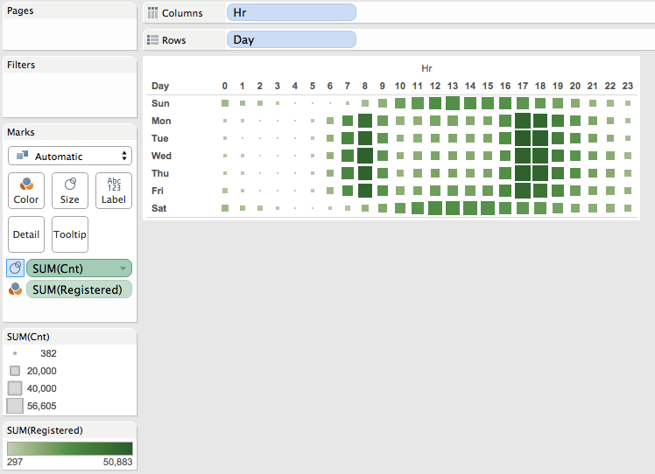

Figure 18

To further visualize, drag Hr out of Columns and off Chart to remove it from the view. Drag Season to Columns. Click the **Bullet Graph** on the Show Me menu on the right. The resulting visualization shows the total Cnt and overlays the registered users by showing black bars as Average and the grey bars as Registered Percent of Average. Specifically, the longer grey bar shows 80% of Registered User Average and the shorter grey bar shows 60% of Registered User Average.

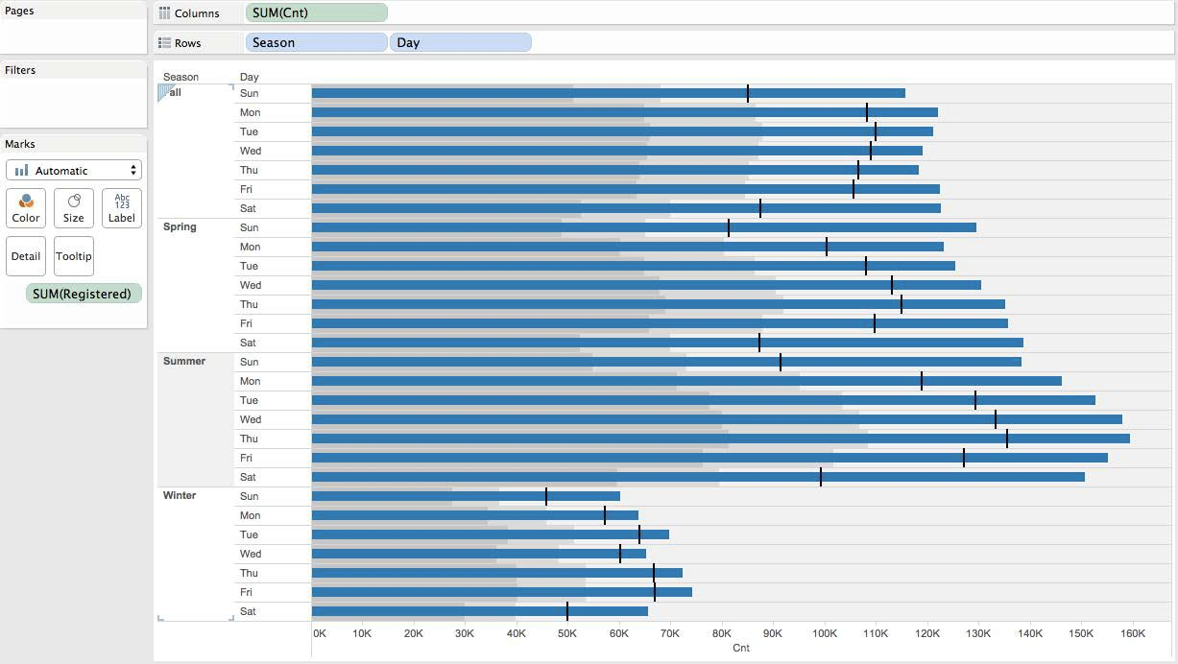

Figure 19

Continue using these variables to practice and try different types of charts and variable combinations. Capture your visualization(s) that you would provide to the decision makers.